Autumn 1 Term 1 - 2026 EYFS Curriculum Overview - Year B
Literacy  We will be basing our work on the stories of The Day you Begin (Whole School, 1 week) , Owl Babies and Where The Wild Things Are. We will also be looking at non-fiction books about forests and woodland animals. We will begin to form letters and hear the initial sounds in words which will help us to start writing words, labelling pictures and looking at the features of a narrative. We will start to identify rhyming words in stories.  Understand the five key concepts about print:  - print has meaning  - print can have different purposes  - we read English text from left to right and from top to bottom  - the names of the different parts of a book  - page sequencing  Blend sounds into words, so that they can read short words made up of known letter– sound correspondences.  Read and understand simple sentences.  Read some common irregular words.  Use phonic knowledge to decode regular words and read them aloud accurately.  Read some common irregular words.  Demonstrate understanding when talking with others about what they have read.  Use some of their print and letter knowledge in their early writing.  Write some letters accurately.  Write short sentences with words with known sound-letter correspondences using a capital letter and full stop.  Re-read what they have written to check that it makes sense.  Use their phonic knowledge to write words in ways which match their spoken sounds.  Write some irregular common words.  Write simple sentences which can be read by themselves and others. Some words are spelt correctly and others are phonetically plausible.  Phonics  Children will have daily phonics sessions. Reception children will learn to hear, say and blend sounds in words and to recognise words by sight. Initially they will focus on learning the phase 2 sounds: s, a, t, p, i, n, m, d, g, o, c, k, ck, e, u, u, r, h, b, f, l  Nursery children will discriminate between sounds, listen out for alliteration, and rhyme and then begin to develop hearing and saying the initial sounds in words.  All children will learn how to listen carefully to stories and poems and be encouraged to talk about their ideas, thoughts, and feelings. | Mathematics-  Measures  Compare objects by length, thickness and weight/mass, using  appropriate language to describe and order them. What makes objects similar and different. Explaining what we notice. Using the language of longer/taller and shorter to compare length or height. Using the language of wider/fatter/thicker and thinner to compare thickness. Using the language of heavier and lighter to compare mass/weight. Exploring that bigger things might not be heavier. Ordering a small set of objects by a given attribute  Mastering Number  Subitising  - perceptually subitise within 3  - identify sub-groups in larger arrangements  - create their own patterns for numbers within 4  - practise using their fingers to represent quantities which they can subitise  - experience subitising in a range of contexts, including temporal patterns made by sounds.  Cardinality, ordinality and counting  - relate the counting sequence to cardinality, seeing that the last number spoken gives the number in the entire set  - have a wide range of opportunities to develop their knowledge of the counting sequence, including through rhyme and song  - have a wide range of opportunities to develop 1:1 correspondence, including by coordinating movement and counting  - have opportunities to develop an understanding that anything can be counted, including actions and sounds  - explore a range of strategies which support accurate counting.  Composition  - see that all numbers can be made of 1s  - compose their own collections within 4.  Comparison  - understand that sets can be compared according to a range of attributes, including by their numerosity  - use the language of comparison, including ‘more than’ and ‘fewer than’  compare sets ‘just by looking’. | Expressive Arts & Design  Encourage the children to engage in the text by playing alongside them and extending their play. Provide them with resources which they can build their play around.  ART Drawing-  Develop drawing skills, a firm hand grip and control of a range of tools and materials. Draw enclosures, lines and shapes and to fill with colour using chalk, crayons, felt tips and pencils accurately to create drawings of owls, Wild Thing characters  Observational drawing of flowers, trees, leaves.  DT  Food-measuring, mixing playdough. Peeling, chopping apples, mixing making apple crumble  Structures- building structures, walls, enclosures, towers with bricks inside & outside  MUSIC  Sing animal action songs with the children such as ‘Two Little Dickie Birds’.  Learn nursery rhymes, songs about animals.  Learn Harvest Festival songs- I’m a dingle dangle scarecrow, Cauliflowers Fluffy, Harvest Samba.  Exploring sound  Exploring how to use our voice and bodies to make sounds, experimenting with tempo and dynamic when playing instruments and identifying sounds in the environment
Communication & Language  The children will learn to listen to others during show and tell and storytelling and by joining in with rhymes and action songs. Sensory box with things for children to describe. Talk, ask and answer questions about families.  Retell a simple past event in correct order  Recreate stories in role play and small world play.  They will talk about what they are doing and explain what is happening  N - Enjoy listening to longer stories and can remember much of what happens  Understand a wider range of vocabulary  Express a point of view  Start a conversation with an adult or a friend  R -Articulate their ideas and thoughts in well-formed sentences  Connect one idea or action to another using a range of connectives.  Describe events in some detail  Engage in story times  Listen to and talk about stories to build familiarity and understanding.  Retell the story, once they have developed a deep familiarity with the text, some as exact repetition and some in their own words.  Listen to stories, accurately anticipating key events and respond to what they hear with relevant comments, questions or actions.  Develop their own narratives and explanations by connecting ideas or events  Learn new vocabulary  Use new vocabulary though the day  Ask questions to find out more  Sing a large repertoire of songs  Listen to and learn rhymes, poems and songs | Forests  Owl Babies and Where the Wild Things Are  1st Half Autumn Term 2026  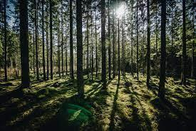  Hooks-  Owl Babies- The children will receive a phone call to tell them there is a surprise box in the wild area where they will find a box containing the book Owl Babies, photographs, feathers, twigs, owl puppets and key vocabulary cards.  Harvest Festival – Friday 20th September  Old Man’s Day Wednesday 2nd October  Black History Week 20-25th October | Physical Development  Daily Busy Fingers activities to strengthen fingers  Pencil control, name tracing, mark making.  Brain break Jump Start Jonny, Wake Up Shake Up, Funky Monkey, Daily Mile, Sticky Kids, PE, playground games, ride-on equipment, trim trail and climbing equipment time  Making bridges across ‘fire pits’ with planks, tyres etc…  Establish regular routines for eating, drinking, washing and toileting so that children become familiar with the rhythm of the day  Introduction to PE  Children will spend time learning basic principles of a PE lesson such as safely using space, stopping safely, using and sharing equipment and working individually, with a partner and group. They will take part in activities which will develop fundamental movement skills such as running, jumping and skipping. Children will also play simple games and begin to understand and use rules.  N -Use one-handed tools and equipment, for example, making snips in paper with scissors.  Use a comfortable grip with good control when holding pens and pencils.  Show a preference for a dominant hand.  Be increasingly independent as they get dressed and undressed, for example putting coats on and doing up zips.  Continue to develop their movement, balancing, riding and ball skills.  Match their developing physical skills to tasks and activities in the setting.  R -Develop their small motor skills so that they can use a range of tools competently, safely and confidently. Suggested tools: pencils for drawing and writing, paintbrushes, scissors, knives, forks and spoons.  Develop the foundations of a handwriting style which is fast, accurate and efficient.  Handle equipment and tools effectively, including pencils for writing.  Progress towards a more fluent style of moving with developing control and grace.  Confidently and safely use a range of large and small apparatus indoors and outside, alone and in a group.
​​Role play  Inside there will have a home corner to give the children a familiar setting in which to play as they start school.  The Day You Begin  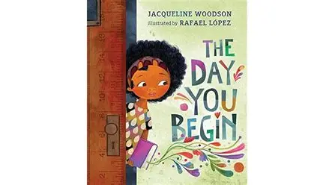  Bing Videos  Owl Babies  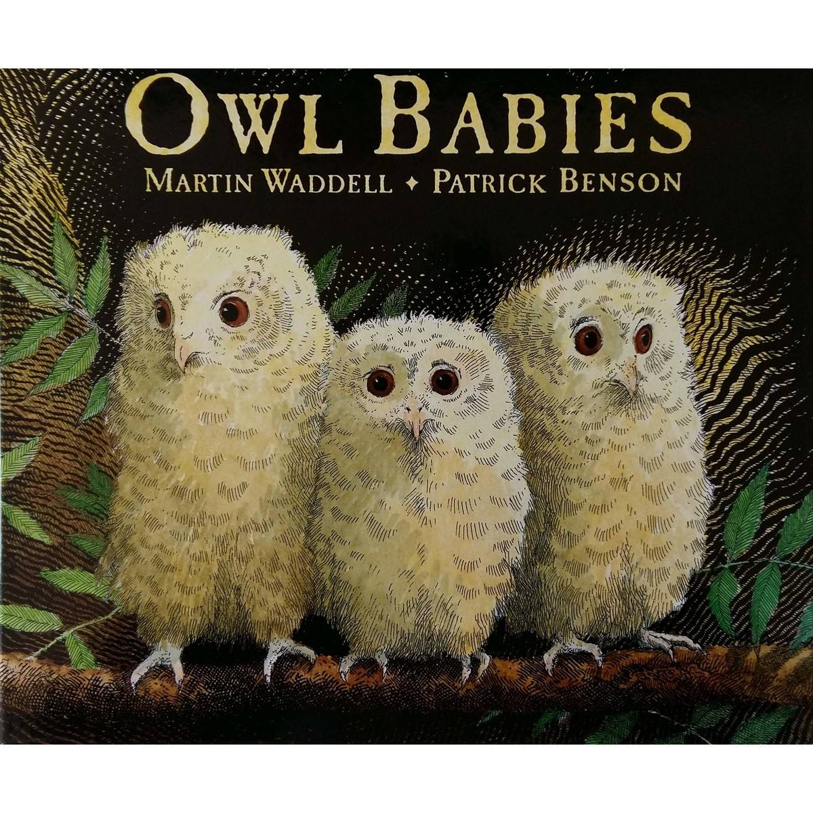  https://vimeo.com/55971653  Where The Wild Things Are  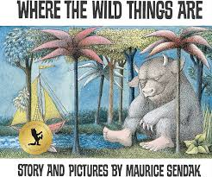  https://www.youtube.com/watch?v=3FsBaRYRPnU  Research  CBeebies | Andy's Secret Hideout | Owls  - https://www.youtube.com/watch?v=8UbKffo9Myc – owls | Personal, Social & Emotional Development  Children will be taught the classroom routines and rules and encouraged to share, take turns and play cooperatively. Children will be encouraged to learn each other’s names and form friendships  Jigsaw Topic:  Being Me In My World  Self- identity  Understanding feelings  Being in a classroom  Being Gentle  Rights and responsibilities  RE – What Makes People Special?  Family  Friends  Role Models  Moses  Jesus | Understanding of the World  The children will learn about forest plants and animals  They will visit the forest area and explore forest school activities one morning each week e.g. Collect leaves to make owl collages. Make owl nests. Find places Owls may live  They will plant bulbs. They will notice the change of seasons and how the plants and weather changes.  Allow the children to create ‘night pictures’ using the class tablet/computer on Paint or 2simple.  Teach the children facts about owls (and other nocturnal animals) provide them with non- fiction books.  Create an ‘investigation station’ for the children with magnifying glasses, mirrors, feathers, sticks etc.  Create a bird bath in the water tray.  Investigate birds, placing bird feeders and water trays outside. Allow the children to monitor and record what they observe. Set up a camera and print out still photos of the birds. Allow the children to annotate these in their own way.  Look at homes and habitats – why do different animals and creatures live where they do?  Observe common garden animals, bugs and birds. Create spotter kits with the children, which could include binoculars, digital cameras, field journals, writing and drawing materials and posters or fact files about common native animals.  Make a regular time for children to talk to the class about anything that they have observed or discovered for themselves  Harvest festival - Farms, farming, food suppliers, scarecrows  The children will play with and operate simple electronic equipment such as Chromebooks cameras, iPads and BeeBots.

