EYFS
Year B
 | Autumn 1  Forests and Feelings | Autumn 2  Superpowers | Spring 1  Homes and Habitats | Spring 2  Feelings and Friendships | Summer 1  Food and Growth | Summer 2  Under the Sea
Core Text | Owl Babies  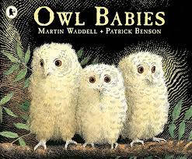  Where The Wild Things Are  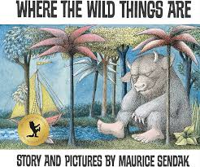 | Ning and the Night Spirits  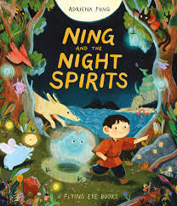  Super Mily and the Super School Day  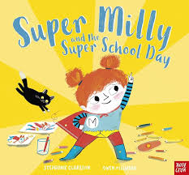 | The Magic Paintbrush  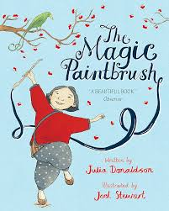  A New House for Mouse  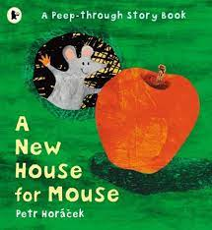 | Night Pirates  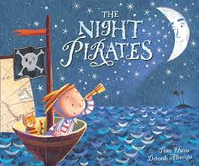  So Much  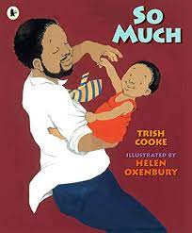 | Handa’s Surprise  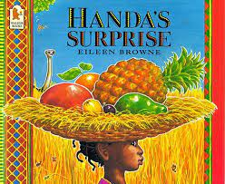  I Will Never, not Ever Eat a Tomato  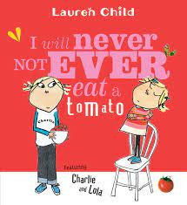 | Anna Hibiscus Splash  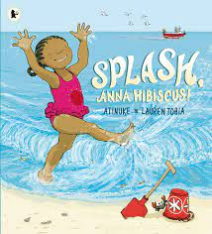  And Tango Makes Three  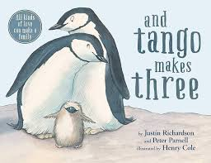
Communication and Language | Explore and sustain ideas through talk | Use talk to ask questions & make connections to their own experience | Re-enacting the story  Repeated text, patterns & rhythm | Give explanations and opinions  Use vocabulary influenced by books | Descriptive language  Expressing self – wants, needs and opinions | Explore, develop and sustain ideas through talk
Physical | Introduction to PE | Fundamentals to PE 2 | Dance 2 | Gymnastics 2 | Ball skills 2 | Games 2
PSED | Manage feelings and emotions – empathy, separation, fear, belonging | Families – sense of self and others including communities | Self-regulation  Building relationships | To develop empathy and other people’s view-points  Making friends/behaviours | Trying new things  Goal setting  Overcoming obstacles | Building relationships  & feeling left out  Comparing past experiences
Literacy | Early reading/ poetry recognise key words & printed text  Hear & retell stories | Rhythm and rhyme  Writing for meaning & purpose - invitations | Write for meaning & purpose - create books  Labelling – speech bubbles | Compose a call and response poem  Maps of journeys  Message centre  Sequencing | Writing for meaning and purpose – aware of audience & giving advice | Writing in role  Non-fiction books and retrieving information
Math | Counting and sequencing  2D shapes  Positional language  More & fewer | Clocks  Day sequencing  Measurements | Patterns  3D shapes  Addition & subtraction  Halving & doubling | Capacity  Money  Number bonds  Ordinal numbers  Counting in 2s  Time  Measures | Distance  Subitising  Sorting  Money  More/less  Making 5 & 10 | 2D & 3D shapes  Numbers and sequencing  Addition & subtraction  Counting in 5s and 10s
Understanding of the World | Forest, wilderness, animals including nocturnal animals | Families and communities | Homes – cities, towns, villages | Animals, living things, habitats, globe and climates | Food, growth, climates | The beach & seaside, sea creatures – oceans, maps & globes
Expressive Arts and Design | Drawing-  Develop drawing skills, a firm hand grip and control of a range of tools and materials. Draw enclosures, lines and shapes and to fill with colour. Observational drawing | Sculpture-  Using playdough, salt dough to make 3-D shapes.Making things out of recycled resources  Craft/ textiles/ Collage-  Making stick puppets  Artist focus: Year A  Wassily Kandinsky  Artist focus: Year B  Yayoi Kusama | Painting-  painting with a range of different brushes, rollers, sponges  Mixing colours from primary coloured powder paint Exploring and naming colours. Adding black or white to change the tone.  Add various materials eg sand to create different textures . | Craft/ textiles/ Collage-  Collage a story character/ animal (dogs/ penguins or tigers  Drawing faces, portraits to show different feelings using different material, wool or papers to add texture or collage effects | Drawing  Observational drawing and printing with fruit and vegetables  Sculpture  Making pictures with food, leaves and forest litter  Printing - repeating patterns with fruit and vegetables | Craft-  Threading around a shape and embellishing  Collage-  Making pictures with different papers to collage eg tissue scrunched or over laid to combine colours  Printing-  Making symmetrical pictures by painting folding paper
Expressive Arts and Design | Food-measuring, mixing playdough. Peeling, chopping apples, mixing making apple crumble  Structures- building structures, walls, enclosures, towers with bricks inside & outside  Mechanisms- making lift the flap cards |  | Food-making valentine biscuits and Easter nests  Structures - making structures in Forest School with sticks and forest litter, balancing, assembling, wrapping with wool & string, junk model homes for a pet or toy |  | Food-Making soup, following a recipe instructions peeling, chopping veg, cooking, tasting  Textiles- joining card and felt/binka by punching holes or threading wool, sting, pipe cleaners to join  Mechanisms- making simple vehicles with wheels or models with moving parts with construction kit

