Application for Leave of Absence from School during term time.

Dear Parent/Carer,
All schools by law must follow the Department for Education’s statutory guidance relating to school attendance. They must use the appropriate national attendance or absence code, and follow the criteria set out within the guidance. The statutory guidance states:
- A leave of absence must not be granted unless there are exceptional circumstances and must be requested in advance.
- A leave of absence must be requested in advance by a parent who the pupil normally lives with
- Schools must judge each application individually, considering the specific facts and circumstances and relevant background context behind each request.
- Where a leave of absence is granted, the school will determine the number of days a pupil can be absent from school.
- A need or desire for a holiday or other absence for the purpose of leisure and recreation would not constitute an exceptional circumstance.
- A school cannot grant a leave of absence retrospectively. If the parent did not apply in advance, the leave of absence should not be granted.
- Where this guidance refers to a parent, the school and/or local authority will need to decide which adult(s) is most appropriate. Generally, parents include:
- All natural parents, whether they are married or not.
- All those who have parental responsibility.
- Those who have day to day responsibility for the child.
Please note all schools are expected to regularly inform parents about their child’s attendance and absence.
Taking your child out of school during term time could be detrimental to their educational progress. If the absence is not authorised and the leave is taken, schools may refer to the Local Authority for legal action. Please find attached information regarding Helping Parents understand Penalty Notice Fines for School Attend

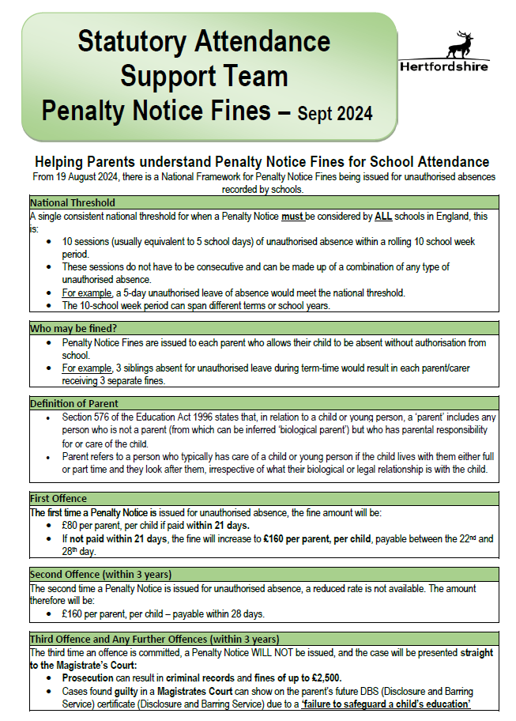

Application for Leave of Absence from School during term time.

Dear Headteacher,

I would like to request permission for leave of absence for my child, a pupil registered at your school for the reasons detailed below (further information can be attached if required).

Pupil’s full name
Pupil’s Date of Birth
Year Group
Class / Registration
Pupil’s full address and postcode

First date of absence
Last date of absence
Date of return to school
Number of school days absent

Please be aware, as per our school’s attendance policy and the Hertfordshire published Code of Conduct relating to school attendance, that the law requires parents to seek permission from the head teacher to take their child out of school during term time. The law states permission can only be granted if:

- An application has been made in advance by the parent the child normally lives with; and
- There are exceptional circumstances.
Please also note that, if on the rare occasion circumstances are deemed exceptional by the head teacher, the duration your child is permitted to be away from school may only be determined by the head teacher.

Reason for request including why you believe your circumstances to be exceptional.
(Further details may be attached to this form)

If you have a child/ren at another school/s, please detail their name/s and which school/s they attend below
Pupil’s name, name of school and school telephone number:

Full name of person making request (note requests must be made by a parent who the pupil normally lives with)
Relationship to child
Full address and postcode (if different from child’s above)
Signature
Date

